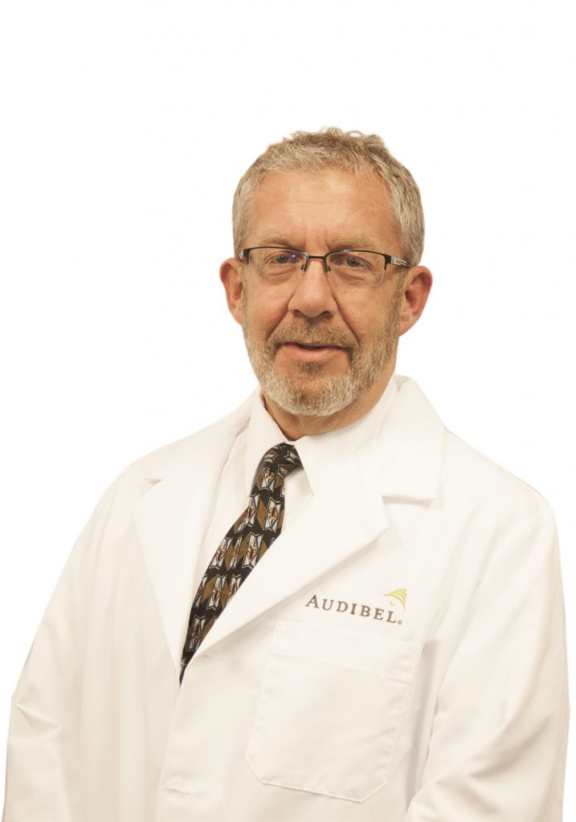

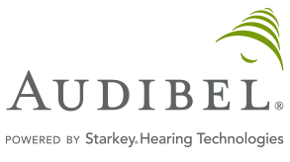
As the owner of the Audibel Hearing Center in Rock Hill and York, South Carolina, I am thrilled to see firsthand the difference a hearing aid can make not only with a single person but a family and friends when their hearing is improved. It’s the best part of my day to see that “light go on in someone’s eyes when they are hearing better and reconnected to their family. I have been involved in the hearing industry for over 15 years and am proud to represent Starkey Hearing products in my practice.

Starkey Hearing Technologies is the only American-owned and operated provider of hearing solutions. With American ingenuity, these hearing aids are built to be strong and long lasting.
They also created the Starkey Hearing Foundation to help make hearing available around the world to others that otherwise would not be able to have access to hearing.

Audibel Hearing Center
2460 India Hook Road, Ste. 102
Rock Hill, SC 29732
(803) 572-3240

https://www.rockhillaudibelhearing.com/

Customer Feedback/Reviews:

- He has worked very closely with my mother to ensure that the aids she received fit comfortably and met her needs. He always checks in with her to make sure she continues to enjoy them and that they are working properly.

- I am extremely appreciative of Michael's concern about my wife's hearing, his attention to detail and expertise in handling our issues and especially his ability to make my wife's hearing ability better with each visit. I will never again question why we should not keep our regular appointments. I have seen some bad experiences in other people’s reviews of hearing devices and feel sorry for them for not having someone like Michael to help them. I contend that it is not the device that is the problem, but it is the person servicing the customer

- You can be assured that Michael will take outstanding care of you and your loved ones, not only at the very first visit, but throughout his years of service to your family.

- I have visited multiple hearing aid centers and have tried multiple hearing aids. The hearing aids provided by Michael at Audibel have been excellent. After only minor adjustments they fit better and improved my hearing over all the other aids I have tried. The only thing better than the hearing aids was the courteous, professional, knowledge and friendly service provided by Michael.

- Expert advice, way beyond customer service, very affordable, top rated hearing aids.

- Michael has been taking care of my Mom's hearing needs for years. He treats everyone that walks in with respect, with each visit spends as much time as my Mom needs and his level of service is unmatched.

